A Practical Activity Report

Submitted for Engineering Design III (UTA-011)

Submitted By:

Satvik Singh 101603307

Submitted To: Dr. Kunal Singh



Electronics and Communication Engineering Department

Thapar Institute of Engineering and Technology,

Patiala-147004,

Punjab,

India

Jan-June 2018

**Experiment2: Transmitter**

**OBJECTIVE:** To Design A Schematic Diagram Of Pulse Width Modulation (PWM) Transmitter Circuit for Gantries Placed At Different Locations On The Path To Be Followed By Buggy Robot.

**SOFTWARE USED:** Eagle 8.0.2

**COMPONENTS USED:**

|  |  |  |  |
| --- | --- | --- | --- |
| **Sr no** | **Name** | **Component** | **Value** |
| **1** | R1 | Resistor | 220 Ω |
| **2** | C1, C2 | Capacitors | 1 µf, 10nf |
| **3** | J1 | Jack | DCI0303 |
| **4** | IC1, IC2 | IC's | 78L05Z, PIC12F629P |
| **5** | D1 | Diode | ZHCS2000 |
| **5** | D2 | LED | SFH482 |
| **6** | R1, R2, R3 | Relay | 22-23-2031 |

**CIRCUIT DIAGRAM:**

**THEORY:**

1. **LED-**A light-emitting diode*(*LED*)* is a two-lead semiconductor light source. It is a p–n junction diode that emits light when activated

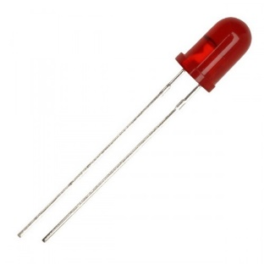

1. **Relay-**A relay is an electrically operated switch. Relays are used where it is necessary to control a circuit by a separate low-power signal, or where several circuits must be controlled by one signal.

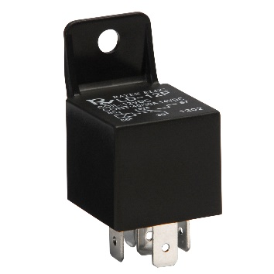

1. **78L05Z -**The 78L05Z series are three terminal positive regulators designed for a wide variety of applications including local, on-card regulation.

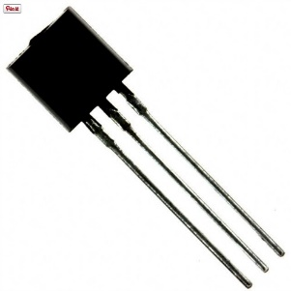

1. **PIC12F629P-**This powerful yet easy-to-program CMOS Flash-based 8-bit microcontroller packs Microchip’s powerful PIC® MCU architecture into an 8-pin package.

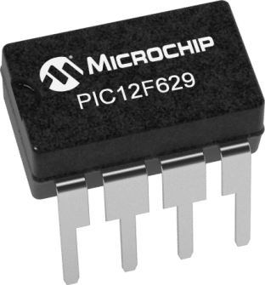

1. **Resistors-**A resistor is a passive two-terminal electrical component that implements electrical resistance as a circuit element. Resistors are used to reduce current flow, adjust signal levels, to divide voltages.

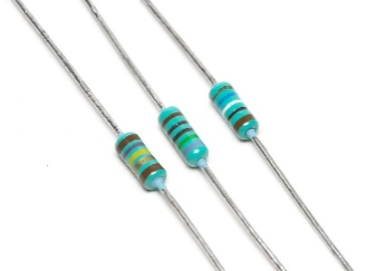

1. **Capacitors-**A capacitor is a passive two-terminal electrical component that stores electrical energy in an electric field.

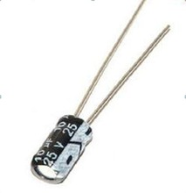

**SCHEMATIC :**

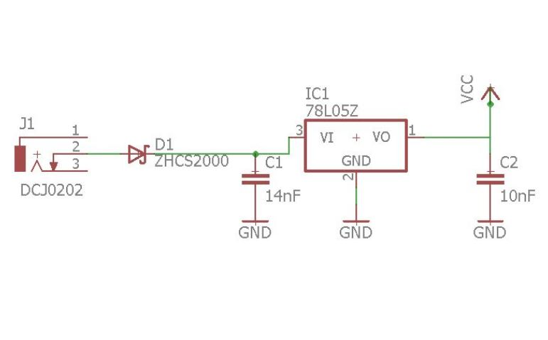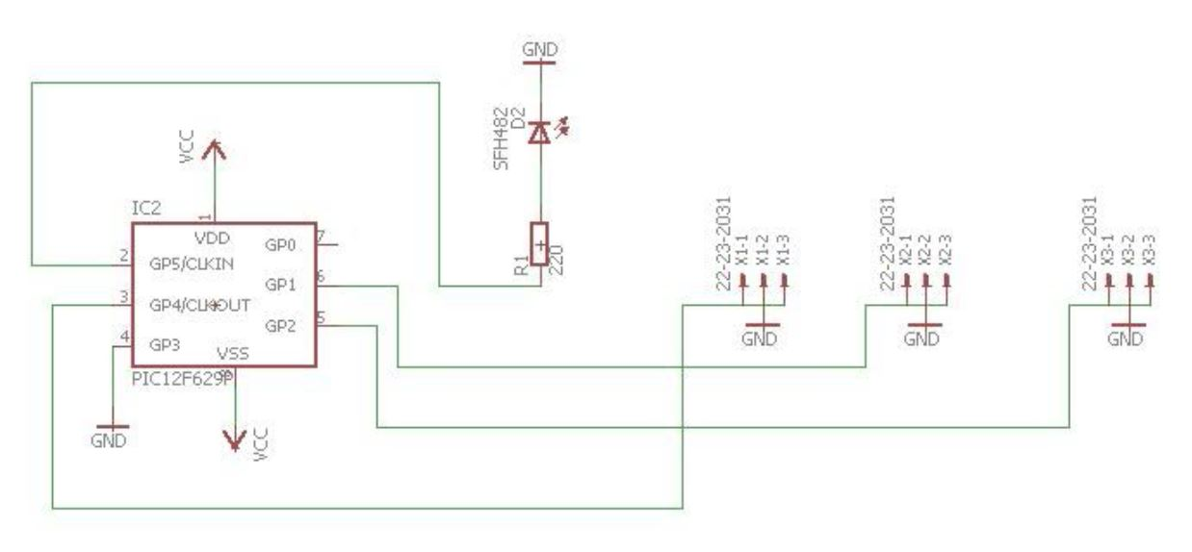

**PCB Layout :**

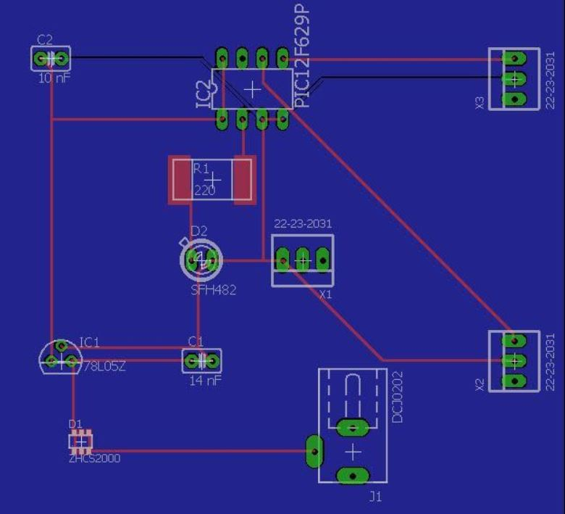

**DISCUSSION:**

A transmitter is attached to each gantry, which sends pulses of different lengths to the buggy. In this way, the buggy can differentiate the gantries. The pulses are send at a specific frequency so that they don’t interfere with other infrared waves.

Signature________